JavaScript Practice – In Class Work

Complete the following JavaScript tutorial (Non Pro version) at
https://www.codecademy.com/learn/introduction-to-javascript
Use the following reference:
https://www.w3schools.com/jsref/default.asp

Download and install WebStorm IDE (which is what we use for Web Services) at https://www.jetbrains.com/webstorm/
- Create a JavaScript program to do a Fahrenheit to Celsius conversion of temperature. Here’s a snippet of the html code to start with.
<html>
<head><title>F to C conversion</title></head>
<body>
<p>
Fahrenheit to Celsius conversion
<!-- TO DO
Create a form that contains a label, text field and a button.
On button click, you must display the converted value on the web page
-->
</p>
</body>
<script src="web.js"></script>
<!-- TO DO
Write a function to get the data from the text field and display
-->
<html>

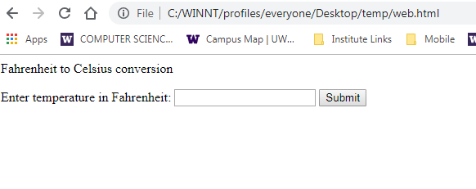
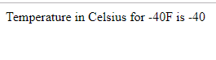

- Create a JavaScript program to display the elements of an object and an array on a web page.
Create an array called toppings with the elements - Cheese, Pepperoni, Mushrooms, Peppers, Onions. Write a function called displayToppings to write and display these to a web page.
Create an object called student with the elements – id, uwnetid, lastName and a function called toString that returns the elements in the format id=1234, uwnetid=mmuppa, lastName = Abraham. Display the contents of the toString function to a web page.
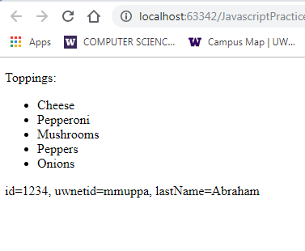

Rewrite your function call(s) to use the= = > notation for functions and with parameters as shown in the web page https://developer.mozilla.org/en-US/docs/Web/JavaScript/Reference/Functions/Arrow_functions

